Installation of Centos

Step 1: Start a system then press Delete Key to can change first boot device to CD-ROM/Removable media in Bios Setup.
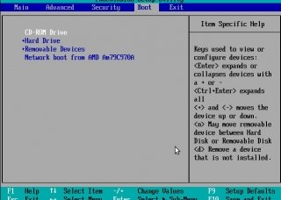

Step 2: Choose “Install or upgrade an existing system” and press Enter.

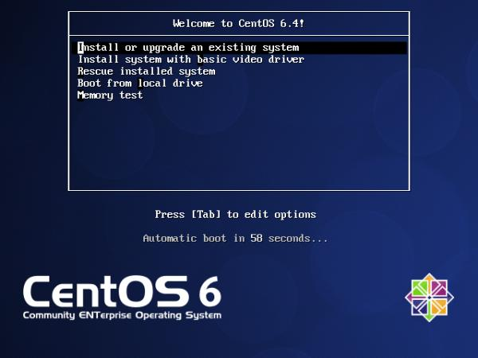

Step 3: You may choose skip installation media check.

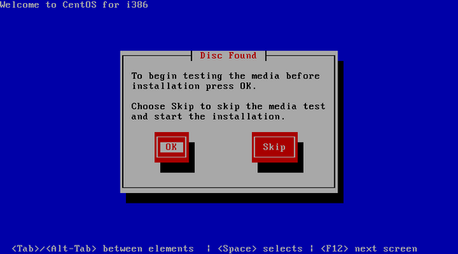

Step 4: CentOS welcome Screen, press Next.

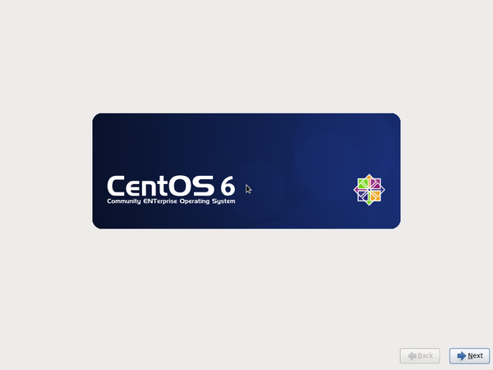

Step 5: Choose language (English) and press Next .

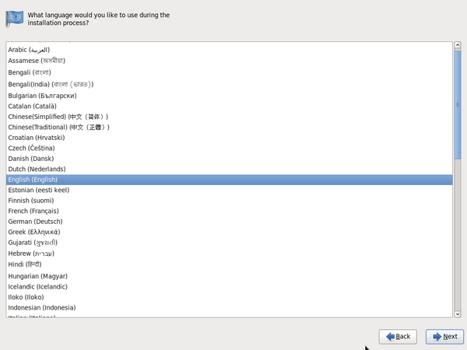

Step 6: Choose keyboard (U.S. English) and press Next .
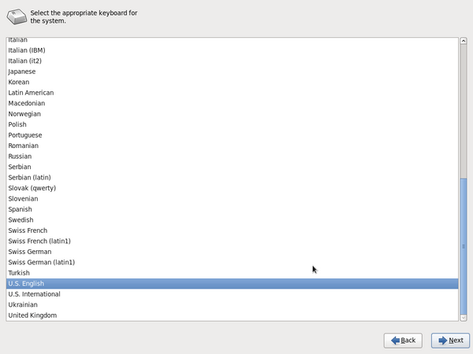

Step 7: Now choose Storage device type . choose “Basic Storage Devices” and
press Next.

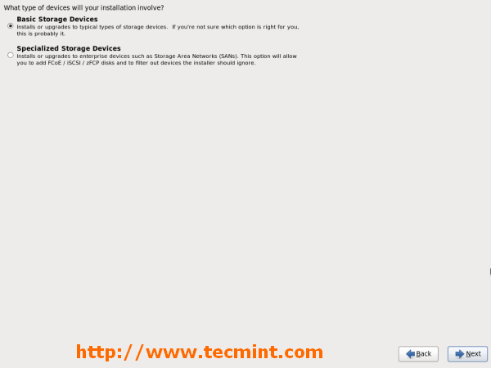

Step 8: It will show warning for using new hard disk . Press yes, discard any data.

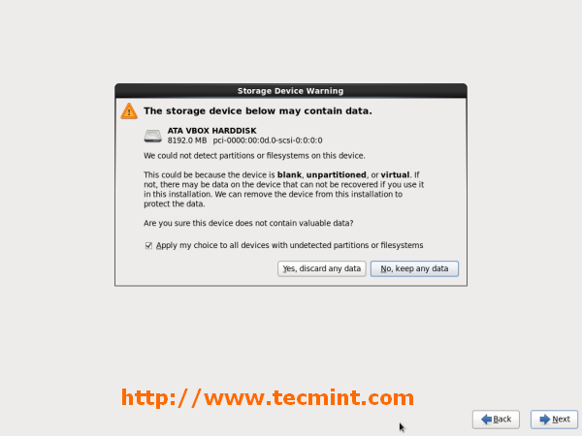

Step 9: Type hostname and press Next .

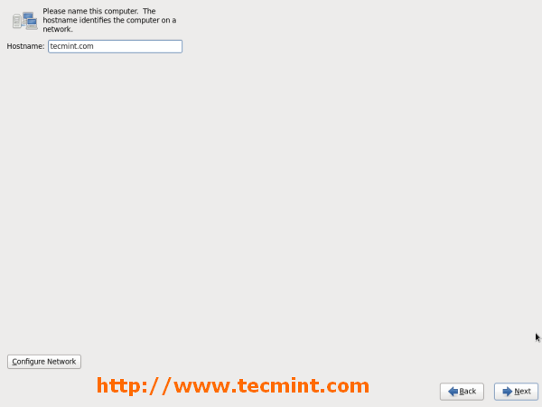

Step 10: Choose Time zone and press Next .

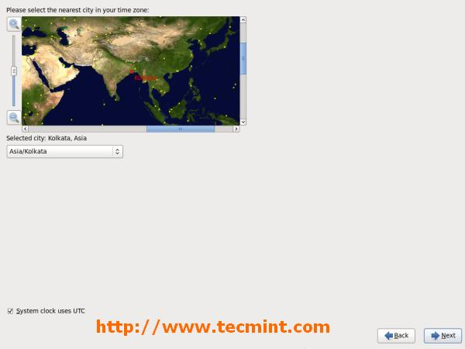

Step 11: Type root password and press Next .

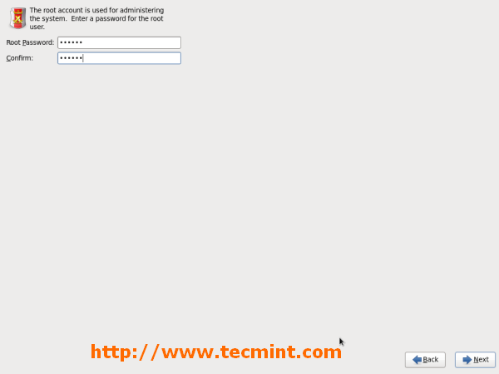

Step 12: Now choose “Create custom layout” to manually create partition and press Next.
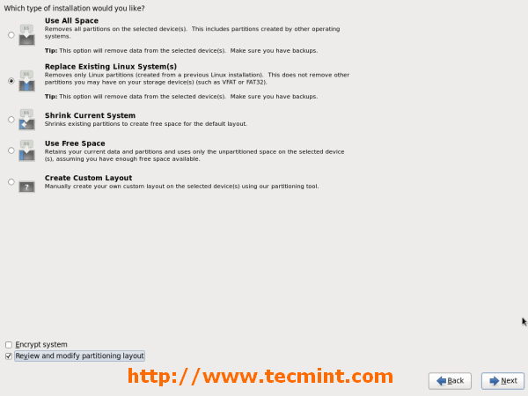

Step 13: Click free space to create / partition, /home partition and swap partitions.
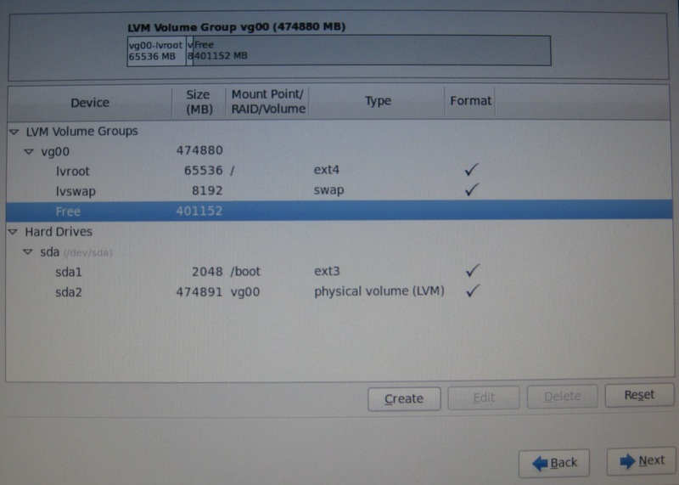

Step 14: It will show warning to creating partition structure on your hard disk . Press “write changes to disk” .

Step 15: If you want to set Boot loader password for security reason, please choose it, otherwise disable it.

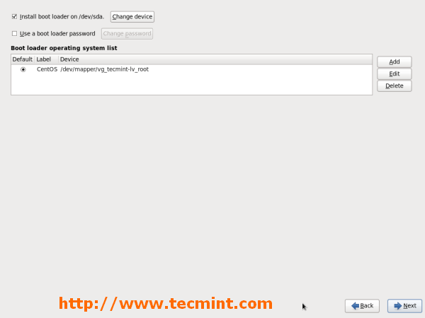

Step 16: Now choose minimal in the list (Server Type : Basic server) and press Next.

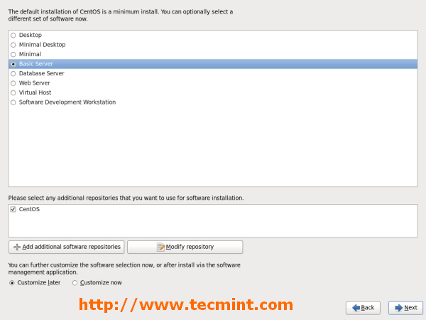

Step 17: Select the applications you want to install and may choose Customize now option to add / remove repositories and click on Next.

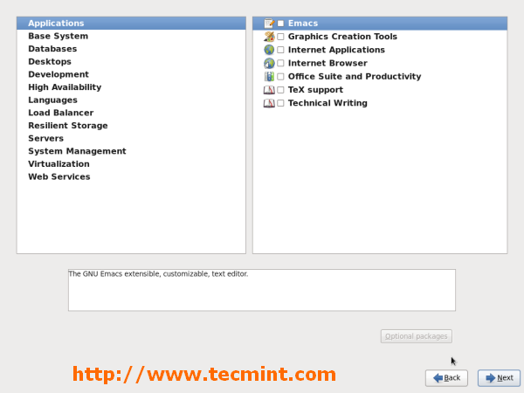

Step 18: Start the installation process.
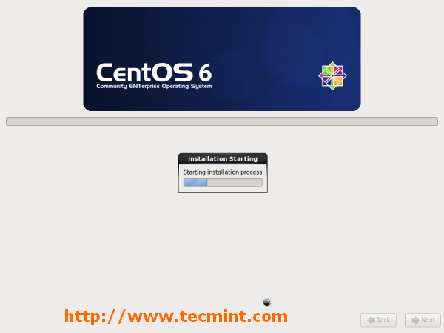

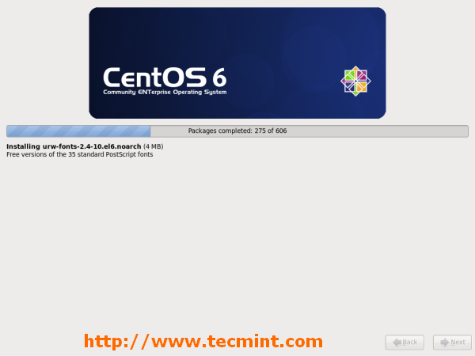

Step 19: Installation Completed. Please remove the CD and Reboot system.
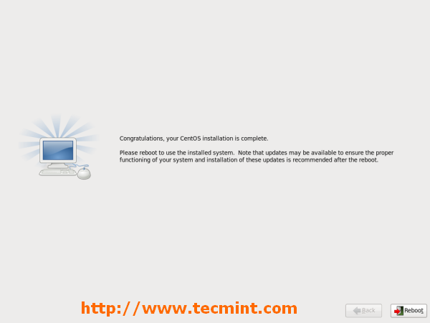

Step 20: Restarting CentOS 6.4 system.
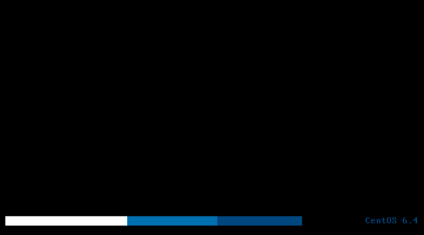

Step 21: CentOS 6.4 Login Screen.
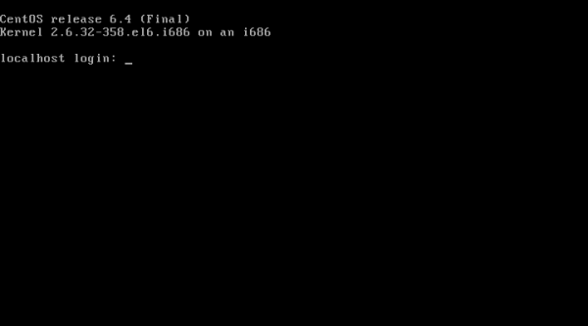

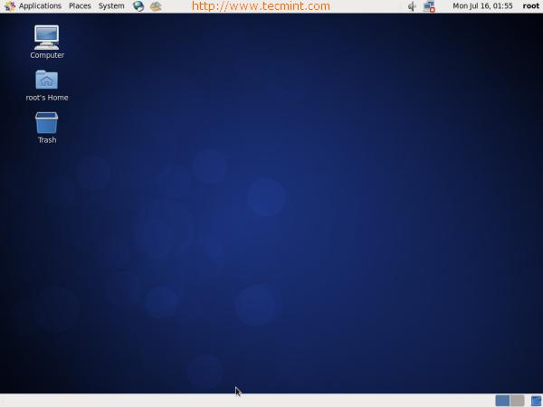

Finish the installation

